



Sri Sri University
Predictive Maintenance for Aircraft Engines & Aviation Safety
HIGH-LEVEL DESIGN
Predictive Maintenance

Baccalaureus Technologiae
Faculty Of Engineering & Technology

SUBMITTED BY
Subham Nayak | FET-BDS-2022-26-019
Indigibilli Harshit | FET-BDS-2022-26-015
Dhruti Deepam Mohapatra | FET-BDS-2022-26-005
Khushi Singhania | FET-BDS-2022-26-013
Lokesh Patra | FET-BDS-2022-26-20

Under the Guidance of
Dr. Pradipta Kumar Mishra
Asst. Professor
Faculty Of Engineering & Technology
Sri Sri University




Table of Contents
- Introduction. .............................................................................................................................. 6
  - Scope of the document ...........................................................................................................................6
  - Intended Audience ..................................................................................................................................6
  - System overview ...................................................................................................................................6
- System Design. ........................................................................................................................... 6
  - Application Design ................................................................................................................................. 6
  - Process Flow ........................................................................................................................................... 6
  - Information Flow .................................................................................................................................... 7
  - Components Design. ............................................................................................................................... 8
  - Key Design Considerations ..................................................................................................................... 8 2.6. API Catalogue .......................................................................................................................................... 8
- Data Design. .............................................................................................................................. 8
  - Data Model............................................................................................................................................. 8
  - Data Access Mechanism ......................................................................................................................... 9
  - Data Retention Policies .......................................................................................................................... 9 3.4. Data Migration ........................................................................................................................................ 9
- Interfaces .................................................................................................................................... 9
- State and Session Management ................................................................................................ 10
- Caching .................................................................................................................................... 10
- Non-Functional Requirements ................................................................................................ 10
  - Security Aspects ................................................................................................................................ 10 7.2. Performance Aspects ........................................................................................................................ 10
- References ................................................................................................................................ 11

1. Introduction
1.1. Scope of the Document
This document outlines the methodology, implementation, and evaluation of predictive maintenance strategies for aircraft engines using machine learning techniques. It delves into the process of leveraging sensor data to forecast potential failures, thereby enabling proactive maintenance practices.
1.2. Intended Audience
Engineers, data scientists, aviation professionals, and stakeholders involved in aircraft maintenance and operations form the primary audience for this document. It caters to individuals seeking insights into predictive maintenance methodologies and their application in the aviation industry.
1.3. System Overview
The system overview provides a high-level understanding of the predictive maintenance framework. It elucidates the data acquisition process, model development pipeline, and the ultimate goal of minimizing aircraft downtime through pre-emptive maintenance actions.
Objectives:
The primary objective of the predictive maintenance framework is to leverage machine learning techniques to forecast potential failures in aircraft engines based on sensor data. By proactively identifying maintenance needs, the framework aims to minimize downtime, optimize maintenance schedules, and enhance operational efficiency in aviation operations.
Components:
The predictive maintenance framework comprises several interconnected components, each serving a specific role in the overall workflow:
- Data Acquisition
- Data Preprocessing
- Model Development
- Model Evaluation
- Deployment and Monitoring
Operational Workflow:
The operational workflow of the predictive maintenance framework follows a cyclical process, iterating through stages of data acquisition, preprocessing, model development, evaluation, deployment, and monitoring. This iterative approach allows for continuous improvement and refinement of predictive models based on feedback from operational data and maintenance outcomes.

2. System Design
2.1. Application Design
The application design delineates the architecture and functionalities of the predictive maintenance system. It outlines the modules responsible for data preprocessing, model training, evaluation, and result visualization.
2.2. Process Flow
Process flow elucidates the sequence of steps involved in predictive maintenance, starting from data ingestion to model deployment. It highlights the iterative nature of model development, wherein insights gained from exploratory data analysis inform feature engineering and model selection.
Model Evaluations:
After training the models, they were evaluated using the test dataset to assess their performance in predicting aircraft engine failures. The following evaluation metrics were calculated:
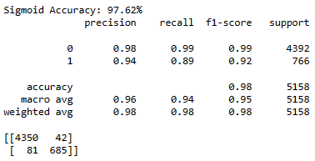
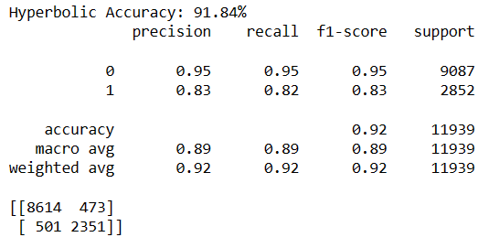

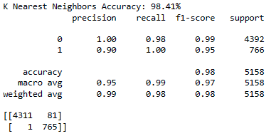
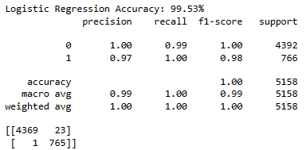

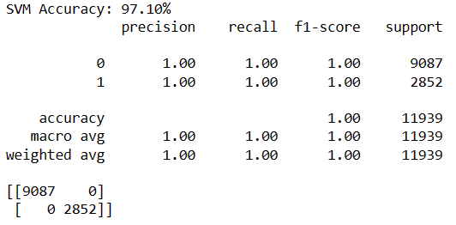
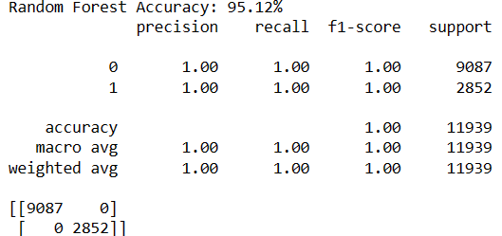

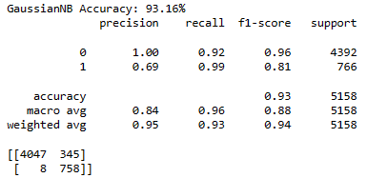
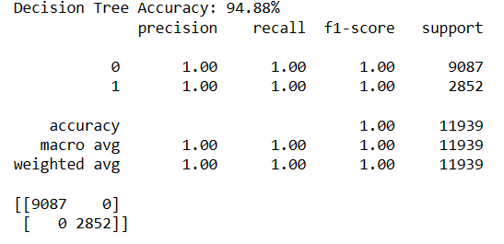

2.3. Information Flow
Information flow diagrams depict the movement of data and insights across different stages of the predictive maintenance pipeline. It elucidates how raw sensor data is transformed into actionable insights through data processing and machine learning algorithms.
2.4. Components Design
Components design outlines the building blocks of the predictive maintenance system, including data preprocessing modules, machine learning algorithms, and evaluation metrics. It emphasizes modularity and extensibility to accommodate future enhancements.
2.5. Key Design Considerations
Key design considerations encompass scalability, interpretability, and reliability of machine learning models. It addresses challenges such as model drift, data quality, and computational resource constraints, ensuring robust performance in real-world deployment scenarios.
2.6. API Catalogue
The API catalogue provides documentation for accessing functionalities exposed by the predictive maintenance system. It facilitates seamless integration with existing infrastructure and enables interoperability with external applications.

3. Data Design
3.1. Data Model
The data model defines the structure and semantics of the sensor data collected from aircraft engines. It specifies the attributes, data types, and relationships necessary for training machine learning models.
3.2. Data Access Mechanism
Data access mechanisms encompass data loading, preprocessing pipelines, and train-test splitting strategies. It ensures efficient data retrieval and manipulation while preserving data integrity and privacy.
Exploratory Data Analysis (EDA)
To gain insights into the dataset and understand its characteristics, an exploratory data analysis (EDA) was conducted. The EDA aimed to uncover patterns, distributions, and anomalies within the data, informing subsequent preprocessing steps and model development.
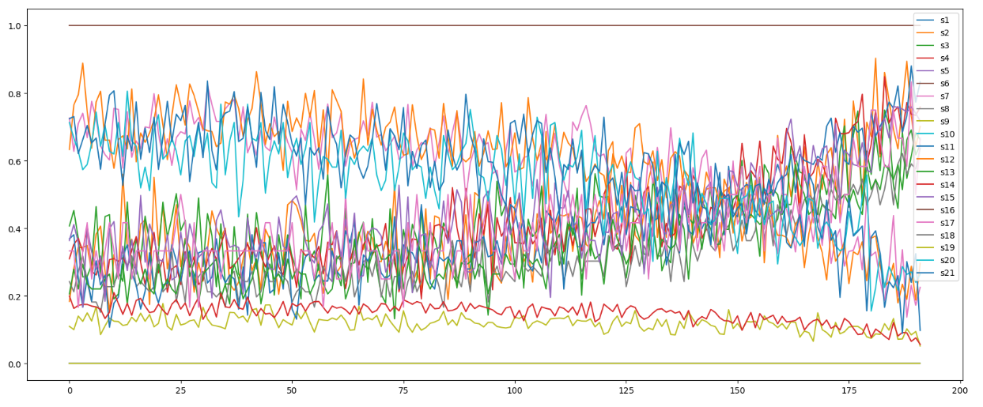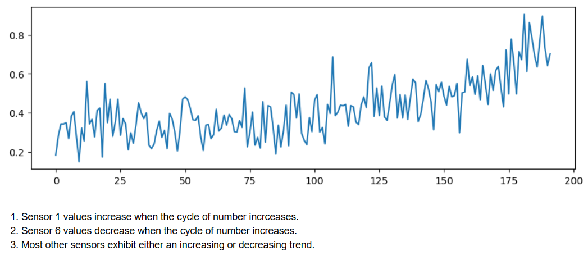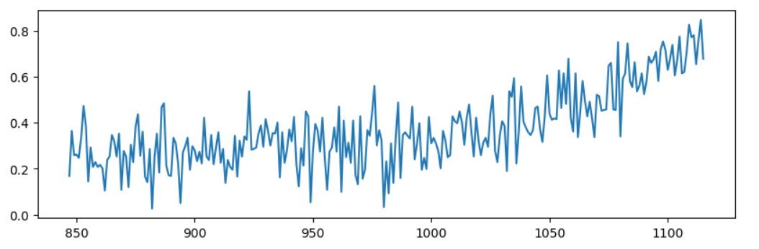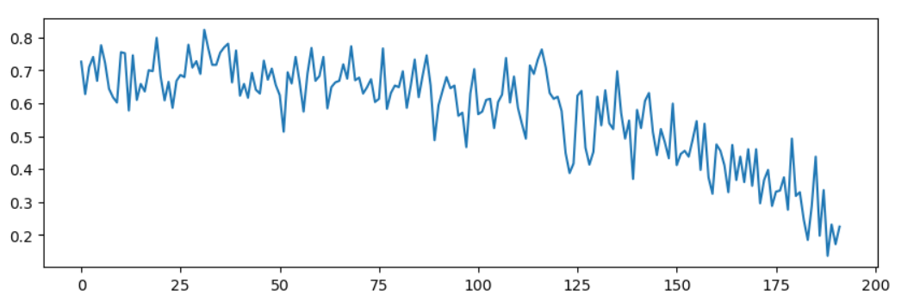

3.3. Data Retention Policies
Data retention policies govern the storage and archival of historical sensor data for future analysis and model retraining. It addresses compliance requirements and data governance considerations to safeguard sensitive information.
3.4. Data Migration
Data migration strategies facilitate the seamless transfer of data between storage systems and environments. It ensures compatibility and consistency across different platforms and data processing frameworks.

4. Interfaces
4.1. User Interfaces
User interfaces provide interactive dashboards and visualizations for monitoring model performance and maintenance alerts. It enhances user experience and facilitates decision-making by presenting actionable insights in an intuitive manner.
4.2. Application Interfaces
Application interfaces enable communication between different modules within the predictive maintenance system. It defines protocols and data formats for exchanging information, ensuring interoperability and extensibility.

5. State and Session Management
5.1. State Management
State management mechanisms maintain the integrity and consistency of application state during model training and evaluation. It handles data persistence, session tracking, and concurrency control to support concurrent access from multiple users.
5.2. Session Management
Session management ensures secure authentication and authorization for users accessing the predictive maintenance system. It safeguards against unauthorized access and protects sensitive data from security breaches.

6. Caching
6.1. Cache Design
Cache design optimizes data access and processing speed by storing frequently accessed data and computation results. It minimizes latency and improves system performance, especially for repetitive tasks such as feature extraction and model inference.
6.2. Cache Implementation
Cache implementation involves selecting appropriate caching algorithms and integrating them into data processing pipelines. It considers factors such as cache eviction policies, expiration times, and cache coherence to maximize cache efficiency.

7. Non-Functional Requirements
7.1. Security Aspects
Security aspects encompass data encryption, access control, and secure communication protocols to protect sensitive information from unauthorized access and data breaches. It adheres to industry standards and regulatory requirements to ensure compliance and mitigate security risks.
7.2. Performance Aspects
Performance aspects focus on optimizing model accuracy, latency, and resource utilization. It involves benchmarking different machine learning algorithms, tuning hyperparameters, and optimizing computational workflows to meet performance targets and scalability requirements.
The performance of various machine learning models in predicting aircraft engine failures was compared based on their accuracy. Table presents the accuracy scores of different models, provides a Tabular representation of the accuracy comparison.
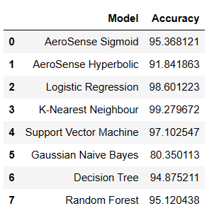

8. References
- Kaggle
- PawRepository
- Govt. Documents

